Lancaster Arts TEST Residency: On Data and Art

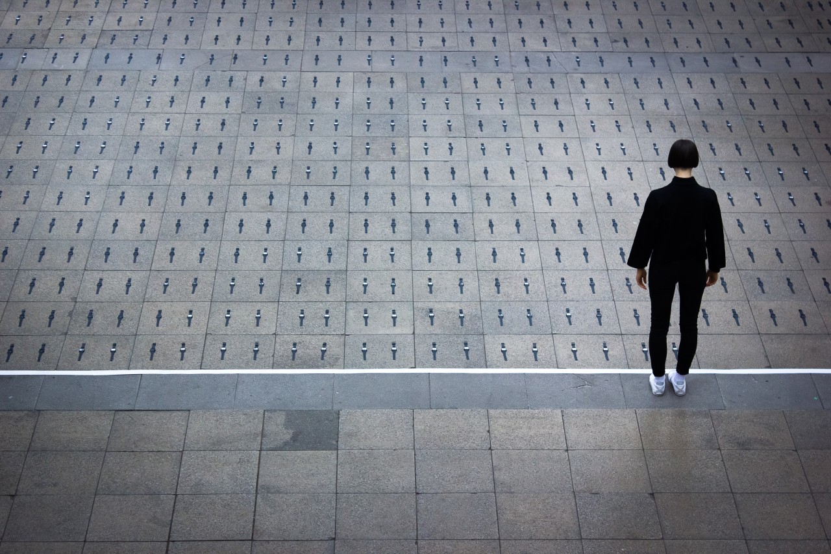
Taking the Time by Gillian Lees and Adam York Gregory (2019)

Lancaster Arts invites proposals for our next Test Residency: On Data and Art, running from 22 – 26 January 2024. This unique programme is dedicated to exploring the interplay of art and data to address pressing social justice issues. We want to enable creative collaborations between academics and artists to enhance the understanding, interpretations and applications of data and artistic practice.

Lancaster Arts wishes to support a contemporary artist based in England who is willing to make open-ended enquiries and explore new territory in collaboration with others. We welcome applications from artists who have extensive experience in working in this area and also from those who are curious but have not explored this previously.

This residency will enable a phase of exploration, for mutual benefit, with Lancaster University academics who use data in their work every day, such as data scientists, and those researching social justice in law, cyber security, health or the world’s environmental challenges. This exploration will take the form of mini residencies within an academic department and/or field trips with one or more researcher/s within the residency period, as well as time to reflect and develop ideas with the support of the Lancaster Arts team. We hope it will also include meetings with activists who use data to inform their work.
The residency will explore the following questions:

How can an artistic practice be of value to understanding and interpreting data and those who work with it?

What new creative approaches can bring the lived experience to data?
What insights can data users and artists mutually exchange to enrich their respective practices?

How can the exploration of art and data go beyond the well-traversed technique of data visualisation?

Note that this residency is for an open exploration/exchange period only, although it may result in a commission for a new collaborative artwork.

Background
Lancaster Arts is a vital component of Lancaster University and receives support from Arts Council England as a combined arts National Portfolio Organisation (NPO). Functioning as an innovative, ideas–led laboratory, Lancaster Arts provides a platform for artists eager to push the boundaries of their work. Notably, the organisation has a long-standing tradition of hosting artist residencies, enabling the exploration of fresh creative practices in the Nuffield Theatre. Please see two contrasting examples: Tara Fatehi Irani and Leo&Hyde.

Every year, Lancaster Arts explores a theme to guide, connect and focus our cross-disciplinary artforms. This year, in 2023, we are exploring Ritual, and in 2024 this will be Flight.

‘Our Nuffield residency was the seed compost that turned the kernel of our initial ideas into something we could begin to see as a show, and the valuable droplets of money became a six-figure production budget. Having studio time, with technical expertise, allowed us to find answers to the questions we began with, and discover which directions we wanted to go. Funded residencies which are open about potential outcomes are vital to robust creative processes and achieving artistic ambitions.’
Alister Lownie from Two Destination Language, 2017 Nuffield Residency recipient

The Residency includes:
- a fee of £1500 for a 5-day residency in the Nuffield Theatre. This amount will include accommodation and travel. Lancaster Arts can help to arrange accommodation on the university campus, if required. (accommodation on campus is approximately £60-£70 a night)
- collaborating directly with academics at Lancaster University in mini residencies with specific departments
- professional documentation of the residency commissioned by Lancaster Arts (outside this budget)
- support from across our whole team with particular emphasis on logistical and creative support from our creative producers
- the brokering of relationships with academics and potential external collaborators for the residency
- extra financial support towards access costs. Specific needs will be discussed with the successful artist.

We would like you to:
- participate in a Creative Gathering on the theme of art and data and social justice during the residency week
- share any outcome/s of your residency with an invited or public group
- create a short ‘response’ to the residency that articulates your process and learning, such as a blog, a podcast, a video diary, etc. by mid-February so this gives you a chance to reflect on the residency.

Criteria for selection:
- a track record of making contemporary art (in any discipline) for at least 5 years
- a curiosity about the interplay of art and data
- a willingness to enter an open-ended collaborative research process, to see where it takes you and your practice
- an articulation of how a research process such as this can extend or deepen your practice in some way
- an interest in collaborating with us at Lancaster Arts

We welcome all applications. We will prioritise artists of the global majority and/or those whose work is primarily based in the north of England (Cumbria, Northumbria, Lancashire, County Durham, Sunderland, Greater Manchester, Tyne and Wear, Merseyside, Yorkshire).

Technical information
This opportunity will take place across the university in research departments, and in the Nuffield Theatre, a ‘black box’ space of approximately 22m wide/deep. The residency will be supported by a Lancaster Arts technician and there is potential for simple lighting, audio feedback, and projection, if desired.

How to apply:
Please complete an application form by following this link.

If you would like to submit your application in a different format for access reasons, please contact us directly.

We will be asking you to address the following questions (we suggest no more than 250 words per answer):

Experience and interest:

- Why are you interested in this residency?

- What is your experience of working with art and data and what excites you about it?

- What do you want to explore in terms of the intersection between your arts practice and data?

- How will this residency extend your artistic practice?

- What research areas at the University are you particularly drawn to?

Practical:

- Propose an outline budget (including fees, accommodation, travel, expenses, materials)

About you:

- Include a short biography / artist statement (NOT a CV)

- Please provide up to 3 links to further information/clips of your work that will support your application.

Key Dates:

Application Deadline: Midnight Monday, (11:59pm) 27 Nov 2023

- Interview shortlisted applicants (online) 5 Dec 2023 (decision by 8 Dec)
- Site visit to Lancaster mid December
- Test Residency: 22 – 26 January (Creative Gathering on 24 Jan, public or invited sharing on 26 Jan)

Please also see our application writing advice on our website: APPLYING FOR OPEN CALLS: HOW TO MAKE YOUR APPLICATION STAND OUT.
Please contact our producer alice@lancasterarts.org with any questions. Please note that we cannot read application drafts.
Don't forget to fill in our monitoring form here.

