

Peter Scott Gallery Charitable Trust - Role Description of Trustees

Visitors at Jez Dolan and Garth Gratrix's exhibition 'How do you make a Queer ritual?" exhibition in 2023
Background
Lancaster Arts (LA) is a National Portfolio organisation (NPO) of Arts Council England (ACE) as a Combined Arts organisation and is an integral part of Lancaster University. The Peter Scott Gallery is an Accredited Museum responsible for the care and oversight of the art collections of Lancaster University. Lancaster Arts has an acclaimed reputation for the presentation, creation and development of innovative contemporary work in all artforms and operates within a university that places arts and culture at the heart of the institution. The different artform spaces work closely together to ensure an ideas-led programme.
The Peter Scott Gallery Charitable Trust (PSGCT) is a registered charity with full legal governance responsibilities and works closely with Lancaster Arts to grow and develop the Peter Scott Gallery collection. PSGCT provides strategic oversight, guidance, and advocacy to support the delivery of PSGCT’s mission and meets quarterly.
The collection as The Trust enables purchases of contemporary art, particularly those arising from the gallery exhibitions as well as receiving donations. We are committed to continuing our conversations on decolonisation. The increased public profile of the digitised collection and partnership with ArtUK marks an opportunity to build the profile of the collection while making meaningful contributions across cultural and higher education sectors through public engagement as well research, teaching and student experience.
Purpose of the Role
The Trustees of PSGCT contribute fully to PSGCT’s direction, development and delivery. Trustees act as ambassadors for PSGCT, helping to strengthen its visibility and value as a living resource which enables innovative research and teaching as well as meaningful public engagement.

Key Responsibilities
Board Leadership
- Support PSGCT in fulfilling its Terms of Reference and contributing to the development of the vision, mission, and strategic plan.
- Attend quarterly PSGCT meetings and the annual retreat with the Lancaster Arts Board, contributing to inclusive discussion, and collective decision-making.
- Contribute to a collaborative and dynamic culture in which trustees are active and mutually supportive.
Strategic Oversight
- Encourage imaginative thinking and creative responsive to change.
- Engage with regional, national and international stakeholders.
Advocacy and Influence
- Represent PSGCT to external stakeholders including funders, partners, artists, and academic and civic leaders.
- Support the development of PSGCT’s profile.
- Promote PSGCT values of creativity, inclusion, environmental responsibility, and public engagement.

Attributes and Experience
Across the group of Trustees will be shared skills and interests including:
- Enthusiasm to engage actively and constructively and work alongside a committed team, both with Lancaster Arts and the Trustee group.
- A demonstrable commitment to environmental justice and an understanding of socially engaged arts practice.
- Capacity and commitment to act as an ambassador and connector for Lancaster Arts and an internationally recognised collection
- Enthusiasm for how we think about, develop and communicate our collection

- Interest in engaging with other galleries and museums on contemporary practice and an on-going commitment to conversations on decolonisation

- A deep appreciation of the possibilities of contemporary art and/or heritage to contribute to social change

- A commitment to diversity, inclusion and equitable access in arts and heritage
Terms of Appointment
- Term of office is a minimum of 3 years and a maximum of 4 years. A Term of Office can be extended once so Trustees can apply for a second term.
- PSGCT trustees will be expected to attend a minimum of 2 meetings a year and attend Lancaster Arts and Gallery events and exhibitions.
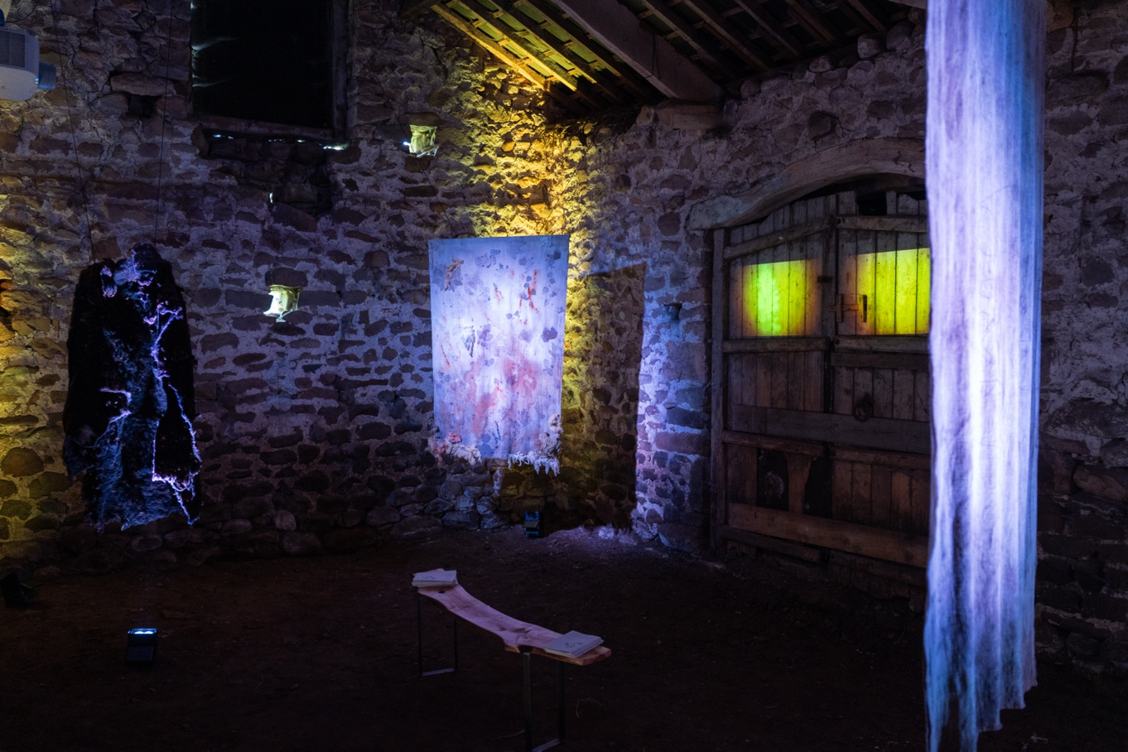
Rob St John's “Are You Lost?” installation as part of Nature Calling in 2025

